ALABAMA LOCKSMITH ASSOCIATION TECHNICAL SHOW
Saturday February 24th, 2018
Doors open at 9 am until 2 pm Saturday
Vendor Registration

Company Name:________________________________________________

Contact Info:_________________________________________________

Address:____________________________________________________

City__________________________State___________________ZIP______

Phone:_____________________________ Fax:_____________________

Email:_________________________ Banner Wording:________________________

*Single booths with pipe and drape: 8’ X 10’ with 2-6 ft tables, 2 chairs, wastebasket,
and sign:____@ $600.00 ea Early Payment gets First Choice payment in full by November 30th, 2018 will receive a 10% discount on booth only

*Electrical Outlets: ____@ $40.00ea Electrical Cord:_____@ $40.00

*Extra 6’ table with drape:___@ $100.00ea *Extra 6’ table no drape:___@ $45.00ea

Names of representatives who plan to attend:

__________________________________________________________________

Please briefly describe the products/services you will be displaying:

______________________________________________________________

Are you interested in sponsoring promotional giveaways? Y / N

Break out tables (in addition to or in lieu of exhibiting)? Y / N

Are you interested in providing bags for guests upon entering the show? Y / N

Are you interested in providing a class and will you need a separate classroom? Y /N
(Fill out class form and / or email locksmithala@gmail.com)
Special requests/concerns, such as booth placement. (Not all requests can be honored.)
_______________________________________________________

Locksmith’s Association Regional Trade Show
2018 Exhibitor Registration

Terms and Conditions

- Each booth is supplied with furnishings as specified in package details in a carpeted ballroom.
- Booths reserved and choice will be made on a first-come, first-PAID basis. Early booking with payment in full by November 30th, 2018 will receive a 10% discount on booth only. Regular booking deadline is January 1, 2018. Late bookings may have non-standard booths or be declined space entirely.
- Your payment is required in order to secure your reservation. You may mail a check payable to Alabama Locksmith Association, Credit Card, can be paid online at www.locksmithala.org
- Written notice of cancellation must be received at least 60 days prior to the event in order to receive a refund or credit! In the event of late booking, notice of cancellation must be received within 14 days of booking in order to receive credit for charges (no refunds).
- You can sell, but do not collect tax
- Each exhibitor is strongly encouraged to donate at least one door prize, which the winner will claim by visiting your booth. Prizes may be present or may be shipped later, and may be of any value. Not all guests are licensed or credentialed locksmiths, so we ask that picks and bypass tools not being issued as prizes unless credentials are verified.
- Event to be held at MARRIOTT HOTELS Birmingham Marriott| 3590 Grandview Parkway, Birmingham, AL 35243 205.968.4508
- Rooms will be $109.00 per night including 2 morning breakfast tickets and internet access with each night stayed. Reservations must be made before January 1, 2018 and are on a first come first serve basis.
- Setup for vendors will be Friday night 6pm until 10pm and then Saturday morning 6 am until 9 am. Doors open at 9 am until 2 pm Saturday.

___________________________ _______________ Booth Choice____
Signature Date

___________________________ _______________ 2nd Choice_____
Name Title

RESERVE YOUR BOOTH TODAY!
Return to Alabama Locksmith Association
1607 Martin St. S Suite 8
Pell City, AL 35128
205-552-8200
locksmithala@gmail.com

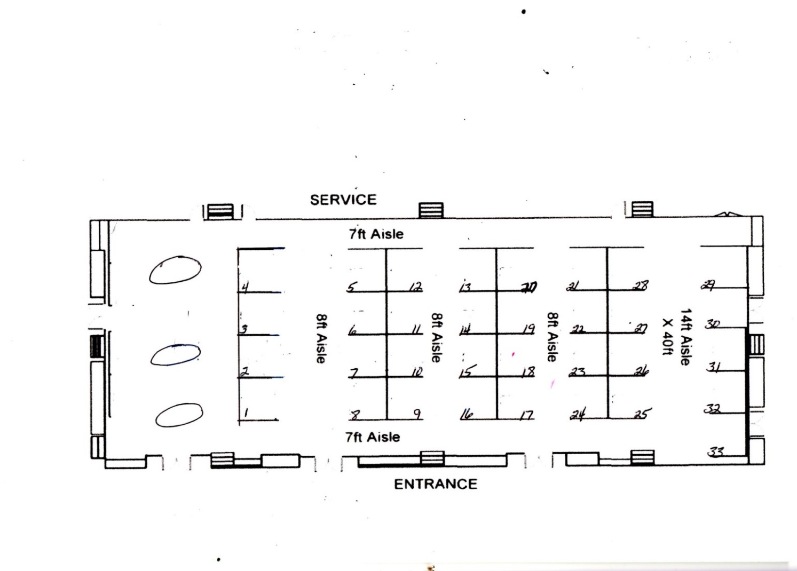
Birmingham Marriott 3590 Grandview Pkwy Birmingham, AL 35243 (205) 968-3775
For special or tall tables or for shipping your display product to have it delivered to your Booth call: 1-800-844-8325 or E-Mail : orders@vealco.com Veal Convention Services

