Alabama Locksmith Association
Officers of Alabama Locksmith Association
Lee Schofield Chairman Alabama Locksmith Association
334-832-4920 1607 Martin St. S 10
Pell City, Al 35128
Bryan Rayburn Co-Chairman
251-895-6098 locksmithala@gmail.com

Barbara McGowin Executive Director www.locksmithala.org
205-552-8200

Calling ALL teachers or potential teachers...  All Locksmith  Alabama Locksmith Association is very pleased to implement our Master Locksmith tier. (See below) submit your resume & syllabus on a class you are interested in teaching. We do have some classes that need teachers. All Classes and syllabus will be looked at for approval.  Send to:  Locksmithala@gmail.com | A Prayer For  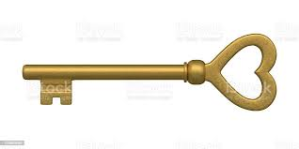  Locksmiths  Dear God,  Watch over me as I work today,  Guide me to help people with their security problems and solutions. Grant me wisdom to make good choices so that my clients get the best life possible, let me always remember the privilege I have to help people protect and manage their valuables and lives.  Amen  Noe Salzar |  | Alabama Locksmith Association is proud to say we are honoring all locksmiths that have passed. We are doing a plaque with their name. Please send us names of locksmiths as we do not want to leave anyone out. Thank you in advance. Also, we have a tier plaque for our vendors please let them know they may contact Alabama Locksmith Association for details.  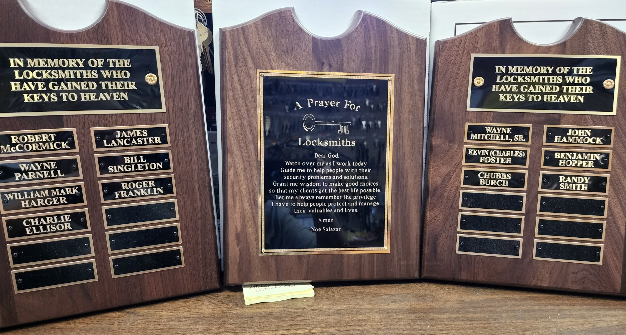  Locksmithala@gmail.com  Up CoFive Day Class & Test 2021  January 25th - January 29th  May Five Day Class & Test 2021  January 25th - January 29th  May 24th - May 28th  August 23rd - August 27th  Oct 25th - Oct 29th  - May 28th  Five Five Day Class & Test 2021  January 25th - January 29th  May 24th - May 28th  August 23rd - August 27th  Oct 25th - Oct 29th  ay Class & Test 2021  January 25th - January 29th  May 24th - MaFive Day Class & Test 2021  January 25th - January 29th  May 24th - May 28th  August 23rd - August 27th  Oct 25th - Oct 29th  y 28th  August 23rd - August 27th  Oct 25th - Oct 29th  Day Class & Test 2021  January 25th - January 29th  May 24th - May 28th  August 23rd - August 27th  Oct 25th - Oct 29th  23rd - August 27th  Oct 25th - Oct 29th  ming Classes  Classes for 2019  Classes will be held at  Holiday Inn  2901 John Hawkins Pkwy,  Hoover, AL 35244  Introduction to Master Keying  Friday December 6th 8-5  Introduction to Small Format  Saturday December 7th 8-5  Introduction to Ethics 101  Sunday December 8th, 8-12  Please see website  www.locksmithala.org

Education is Key
We all need CEU’s to keep up to date with licenses. Get your CUE’s early they are good for 3 years. Locksmithala.org.
Alabama Locksmith Association
1607 Martin St. S Suite #10
Pell City, AL 35128
Web: locksmithala.org
To all locksmiths, we are updating our computer. We are asking that you please fill out all information and send it back to us. You can e-mail or mail it back. Even if you think we have your information please send this back. We appreciate all of you tremendously. Thank you in advance for your time.
- Name ____________________________________________
- Residential Address_________________________________
- E-mail ____________________________________________
- Phone ____________________________________________
- Company, do you own your own business or work for someone ________________
- Company address_____________________________________________________
- Company Phone ______________________________________________________
- Company e-mail ______________________________________________________
If you have taken the test within the last 5 years
- Are you currently working as a locksmith ________________________________
- Do you own your own business or work for a company _____________________
- Name of company ___________________________________________________
- Address ___________________________________________________________
- Phone ____________________________________________________________
- E-mail ____________________________________________________________
- If you are not working as a locksmith, please let us know why __________________________________________________________________________________________________________________________________
Thank you
Alabama Locksmith Association
Tammy Lee e-mail tammyleelocksmith@gmail.com e-mail locksmithala@gmail.com
Alabama Locksmith Association is proud to say we are implementing our tier to become
Alabama Locksmith Association
Alabama Locksmith Association Proficiency Registration Program

Alabama Registered Licensed Locksmith (ARLL)
The first level of locksmith certification is Alabama Registered Licensed Locksmith (ARLL). A ARLL has taken the 5-day course and passed the test to receive their license for locksmith. A ARLL has a good working knowledge of general locksmithing. Must pass test with no less than a 75%. Must have current Locksmith License to move forward in locksmith levels and education.
40 Hours and 24 CEU.
Lever Tumblers | Basic Safe Knowledge
Knowledge of Basic Master Keying | Door Closures
Basic Domestic Automotive | Ethics and Codes
Cylinder Servicing | Key Duplication
Key Blank Identification | Key Imprisoning
Professional Lock Opening Techniques | Lock Servicing

The second level Alabama Registered Professional Locksmith (ARPL)
The second level of locksmith certification is Alabama Registered Professional Locksmith (ARPL). A
ARPL has earned their ARLL, currently licensed, and has succeeded in an additional 15 elective categories. With a minimum of 2 classes in automotive and residential and commercial. A ARPL has an advanced knowledge of general locksmithing and many specialized areas. Must pass all 15 classes with no less than a 75% on each test. There must be a test in each category for certification. Choose from list below. Cannot take a duplicate class for qualification. Cannot challenge test to qualify.
The third level Alabama Registered Master Locksmith (ARML)
The Highest Level of Locksmith certification is Alabama Registered Master Locksmith (ARML). A ARML has reached the highest level of Alabama Locksmith Association Proficiency Registration Program. With an additional 2 classes in automotive and residential and commercial. A ARML has advanced knowledge of most areas of locksmithing and electronic security. Must pass all 10 classes with no less than a 75% on each test. There must be a test in each category for certification. Choose from list below. Cannot take a duplicate class for qualification. Cannot challenge test to qualify,
Classes for
ARPL and ARML

Small Format Interchangeable Cores | Electronic Access Control Certification
Large Format Interchangeable Cores | Basic Electricity Running Low Voltage Wiring
Beginner Safe and Lock Construction | Key Impressioning 102
Door Closures and Push Bar Installation | Safe Opening and Servicing and Lock Installation
Master Keying 101 | Tools and their Usage
Safe Deposit, Cabinet, Furniture & Mailbox Locks | Automotive Locksmithing 101
Ignition Tear Down and Removal from Vehicle | Insurance for your Business
Simplex | E-Plex
Automotive Locksmithing 102 | Volkswagen Generating a Key
Advanced Electronic Control (must be EAC certified) | Automotive Door Lock Removal, Re-Pin and Installation
Soldering Class | Safe X -10 and CDX-10
BMW Generating a Key | Safe Manipulation
Safe Penetration and Scope Techniques | Decoding of Keys
Handwritten Master Key System | High Security Locks & Servicing
Hand & Key Change of Combos | Lishi (Residential, Commercial & Auto)
Lock Shop Management 101 | Advanced Shop Management
Servicing Aluminum Storefront Doors | Motorcycle Locksmithing
Introduction to Master Keying | Master Key System Decoding & Expansion
More Classes will be ADDED. Please submit your resume and syllabus if interested in teaching.
Go to Locksmith.org to sign up

Beach Classes

We have 4 classes this year at the beach.
Hilton Garden Inn
23092 Perdido Beach Blvd
Orange Beach, Alabama 36561

Auto Locksmithing 101 Sept 9

Auto Locksmithing 102 Sept 10
Introduction to Master Keying Sept 9
Master Key System & Decoding Sept 10
Go to Locksmith.org for all information
Sign up for classes limited space available
Get your group rate for hotel the deal ends soon BEACH Hilton Garden Inn
23092 Perdido Beach Blvd
Orange Beach, Alabama 36561

Beginner Classes
July FULL
October 24-28
January 23-27/2023
BEACH CLASSES
Auto Locksmithing 101
September 9
Auto Locksmithing 102
September 10
Intro to Master keying
September 9
Master Keying System Decoding & Expansion
September 10

Please check for any changes to dates or classes by checking website, thank you.

IF YOU DO NOT HAVE ACCESS TO a COMPUTER, YOU CAN USE COUPON BELOW TO SIGN UP FOR CLASSES
THANK YOU

SEATS WILL NOT BE HELD UNTIL PAID FOR IN FULL…. SIGN UP EARLY TO INSURE YOU GET A SEAT!!!! ALA has the right to cancel or change dates please call or check website.
SIGN UP SHEET CHECK OR MONEY ORDER MADE OUT TO ALABAMA LOCKSMITH ASSOCIATION
Company__________________________________________ Phone______________________
Class______________________________________________________ Date_________________
Name_____________________________ Name____________________ Name__________________ Name_____________________________ Name____________________ Name__________________
Name_____________________________ Name____________________ Name__________________

Class______________________________________________________ Date_________________
Name_____________________________ Name____________________ Name__________________ Name_____________________________ Name____________________ Name__________________
Name_____________________________ Name____________________ Name__________________

Mail back to: Alabama Locksmith Association 1607 Martin St. S Suite 10 Pell City AL 35128

